Please add a third color blue led facial therapy to the home page

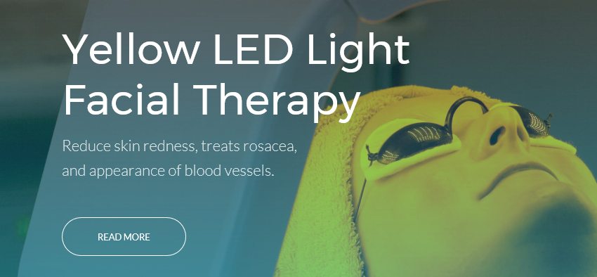

In the second paragraph, can you replace the paragraph with the following:

When the correct wavelength energy interacts with the skin, the dermis layer will convert the wavelength into energy allowing the skin cells to do their job better. This includes collagen production which gives your skin a healthier fuller look and gives your skin elasticity and a firmer look. Therefore, LED light therapy helps your body restores to the level when you were in our 20’s. Take a peek at what we have to offer.

